*Florida International University*

*School of Computing and Information Sciences*

CIS 4911 - Senior Capstone Project

Software Engineering Focus

Feature Document

User Story #781

**Team Member:**

Jorge Nonell. Eric Aguiar, Alex Karpis, Chris Naranjo

**Product Owner(s)**:

Francisco Ortega

**Mentor(s)**:

Francisco Ortega

**Instructor**: Masoud Sadjadi

**User Story** **#781 – Improve Build System**

### Description:

* **As a developer I would like to improve build system so that it takes less time and effort to build going forward as we work with the project.**

### Acceptance Criteria:

1. **Get project to build in vs2015**
2. **Add scripts to make the project build with one click**
3. **Add dependencies to github**

**Use Case #781 – Improve Build System**

Use Case:

Reengineer build system to make this process be faster and easier on subsequent project builds.

Details:

Actor: Developer

Pre-conditions:

* Is running a Windows developer machine.
* Has git installed on their machine.
* Has Visual Studio 2015 installed.

Description:

* Use case begins when the developer gets a fresh copy of the project and needs to get it running.
* The user story ends when the program runs on the developer’s machine.

Post-conditions:

A developer can easily pull down dependencies and build the project

Decision Support:

Frequency: Often. Developers need to build often

Criticality: High. Enables developers to work more efficiently

Risk:Low. New build should not adversely affect how others work

Constraints:

Reliability: Very Reliable.

Performance: No performance improvements

Supportability:

Must run on Windows

Modification History:

Owner: Jorge Nonell

Initiation date: 06/07/2016

Date last modified: 06/07/2016

**Use Case Diagram**

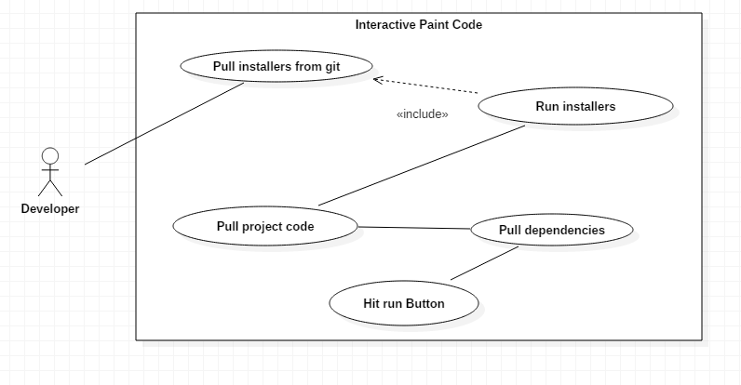

**Unit Test**

Sunny Day Tests

Test Case: Build Works

Test Purpose: Ensure that user can still draw on screen after drawing is refactored..

Test Setup:

* Pull down Installers from git repo
* Run installers
* Pull down project code
* Navigate to “Code/TouchPoints/vs2015”
* Pull down dependencies from repo

Test Output:

Project builds and runs successfully

Expected Output:

After pressing run button screen, the build succeeds and the program runs correctly

**Integration Test**

Asking a new developer to pull down all the project files and running them on their local machine should work.

**User Guide**

To get the build going you have to:

1. Pull down the installers from git: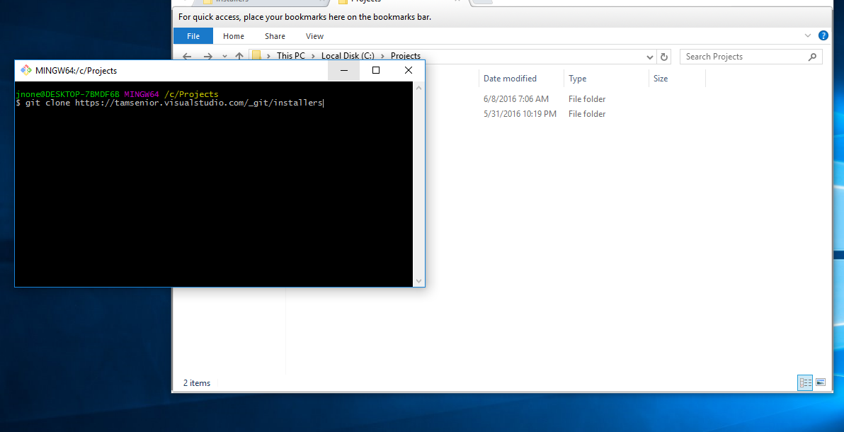
2. Run each installer: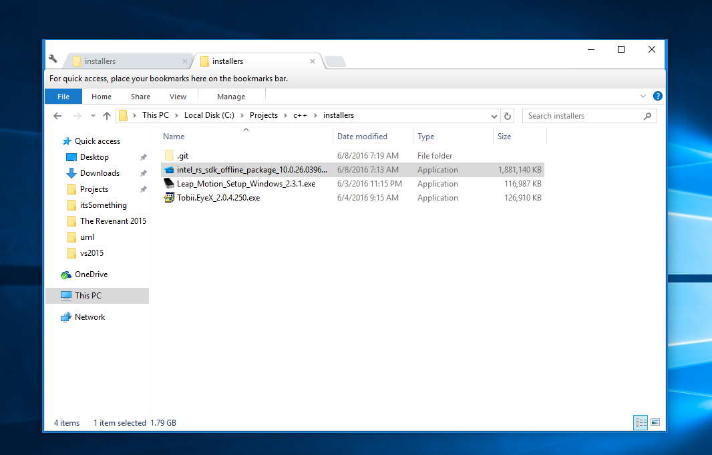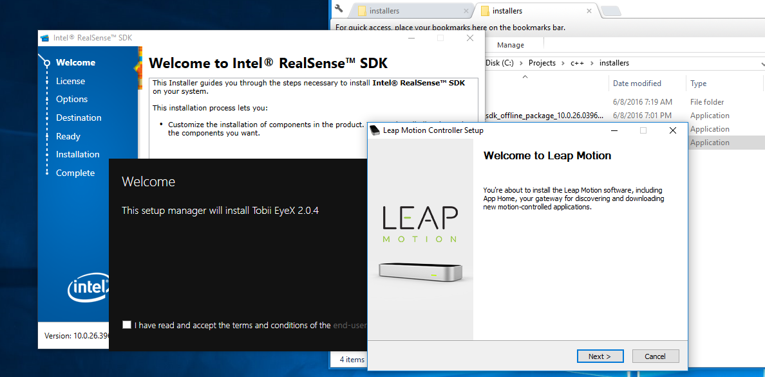
3. Pull the source code: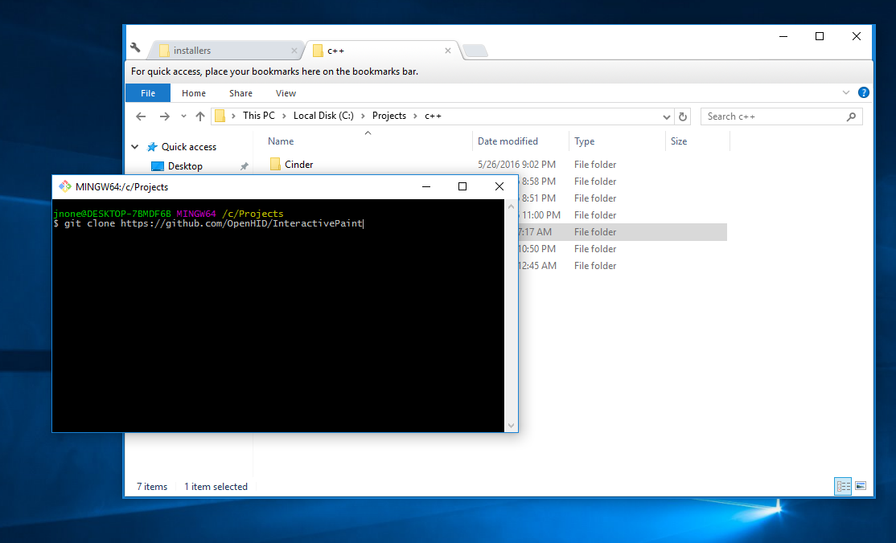
4. Change directories to “InteractivePaint\Code\TouchPoints\vs2015” and pull down dependencies: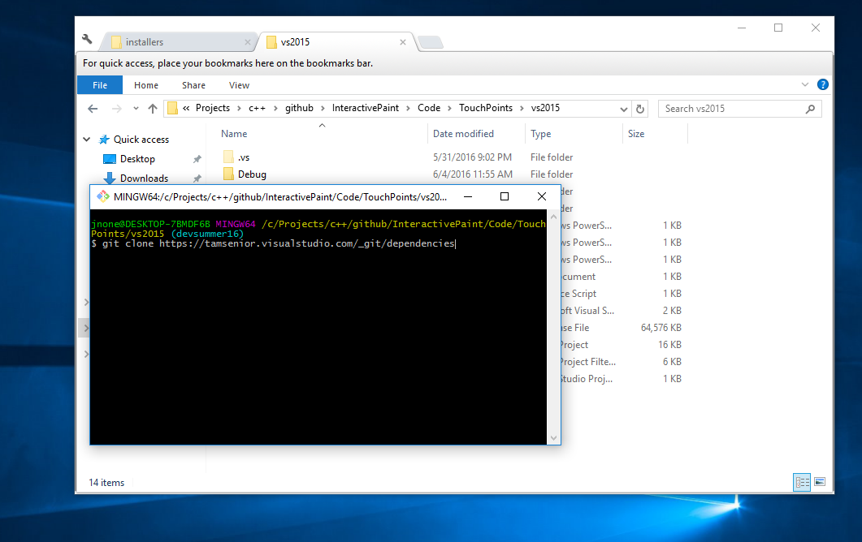
5. Open project solution in Visual Studio 2015 and hit run: